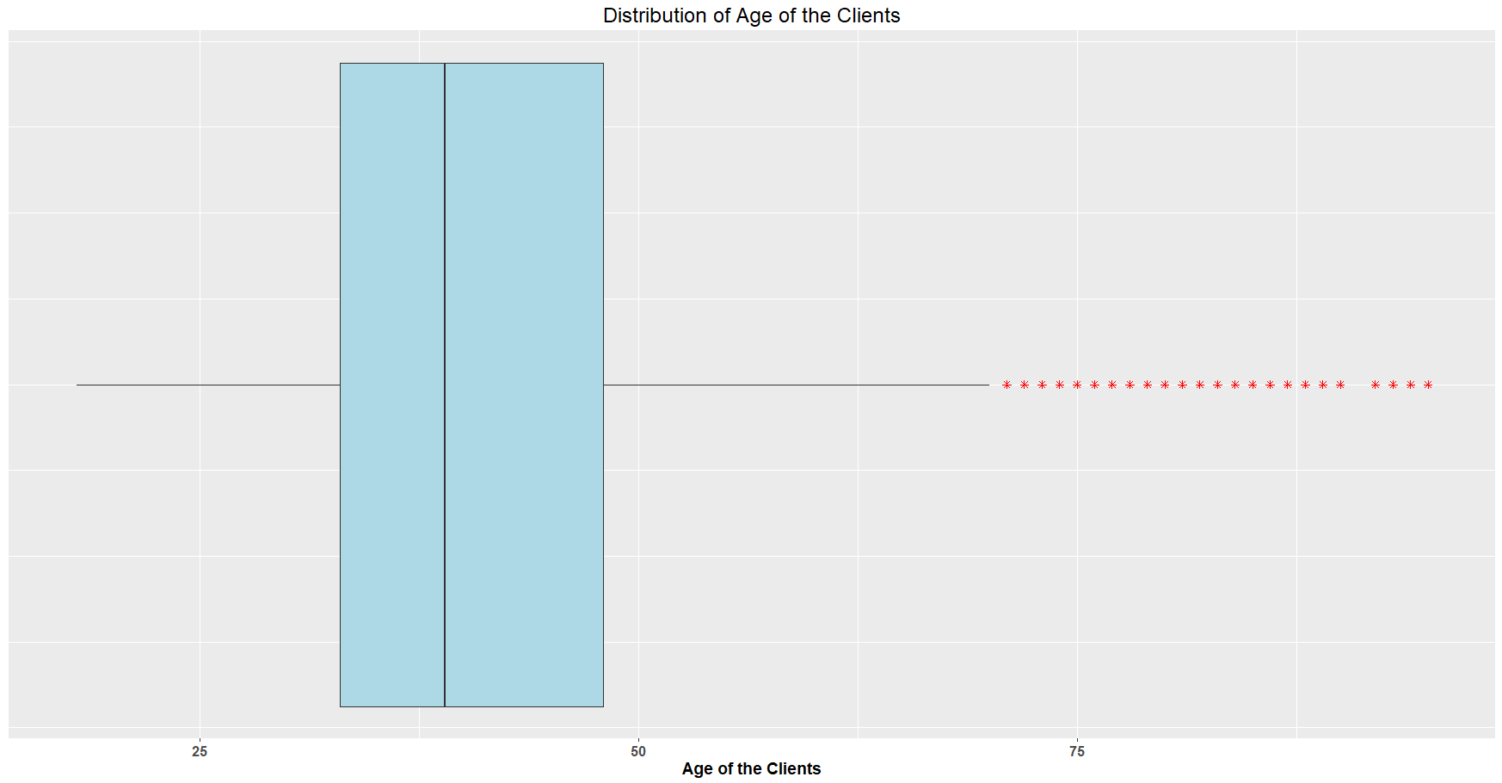

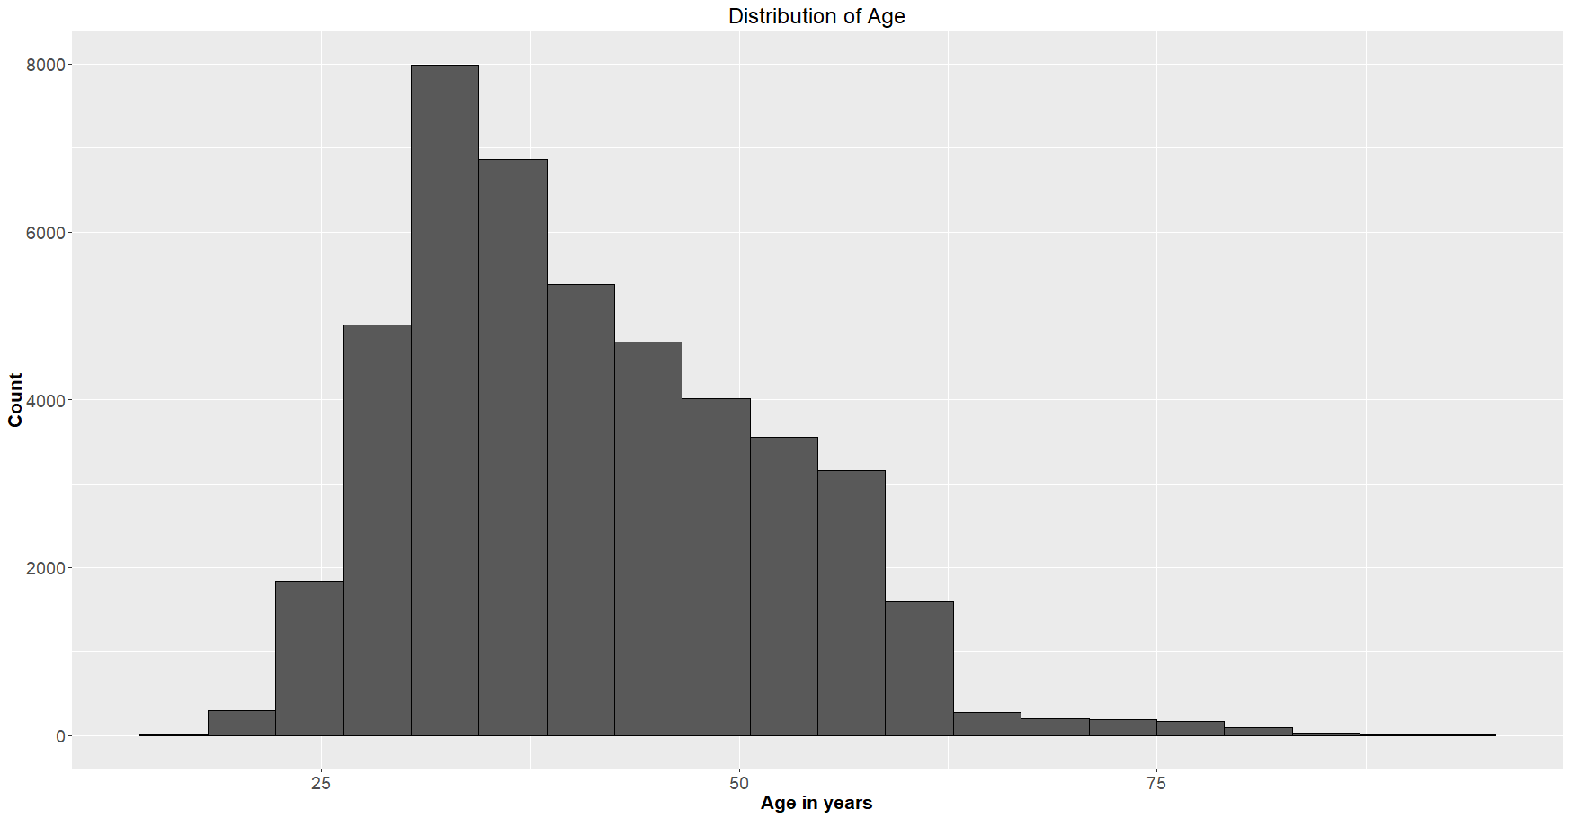

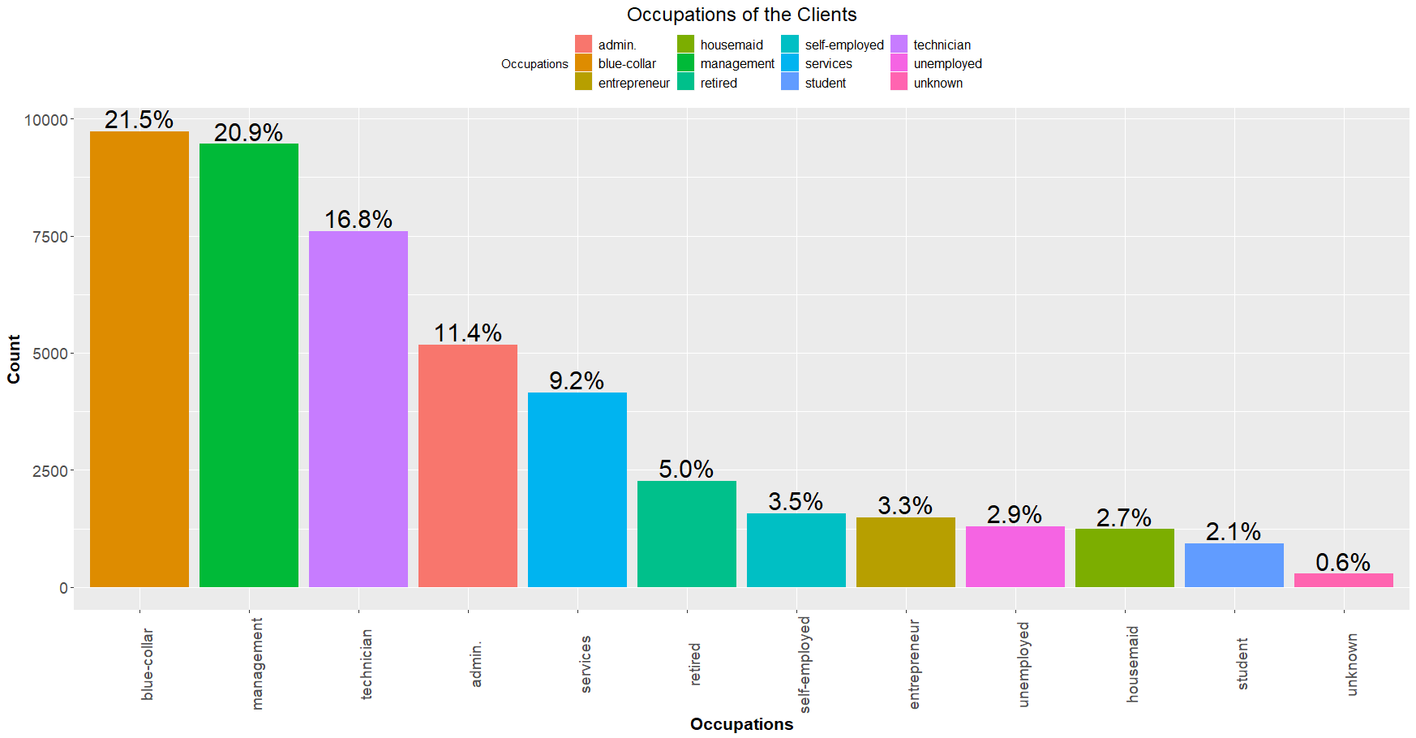

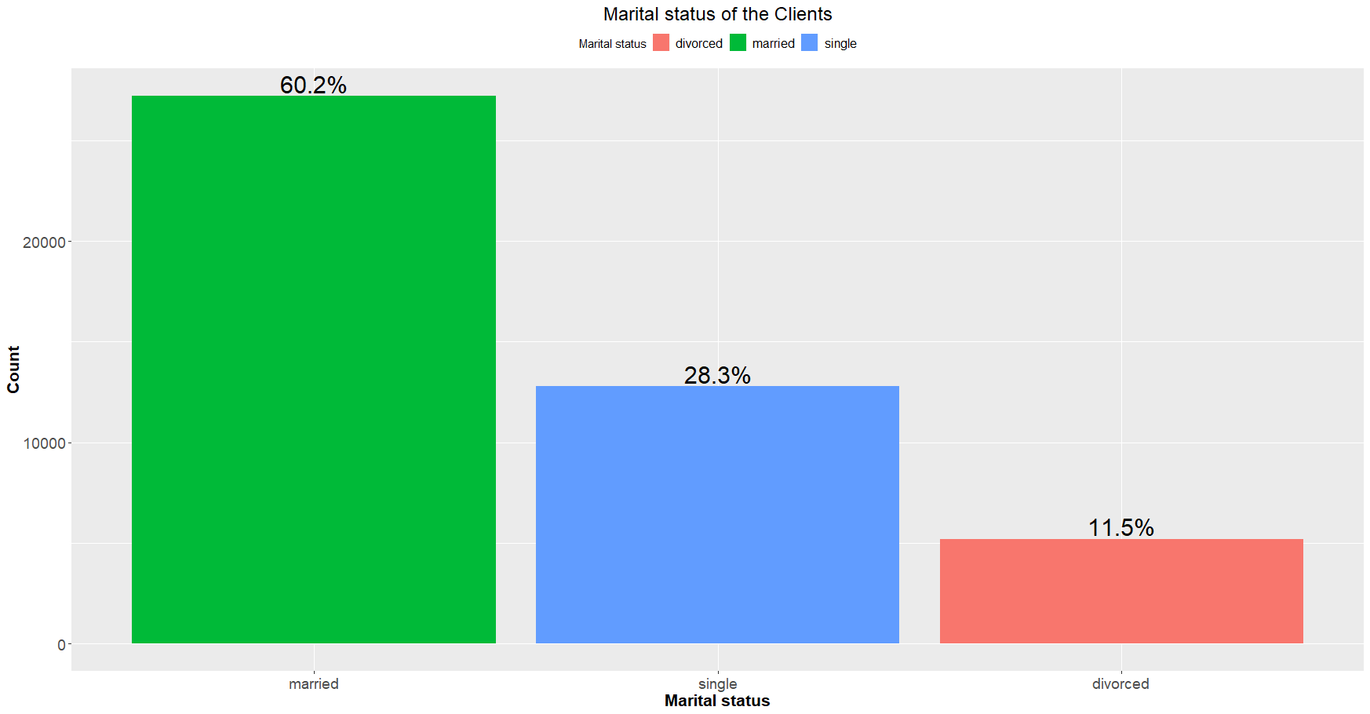

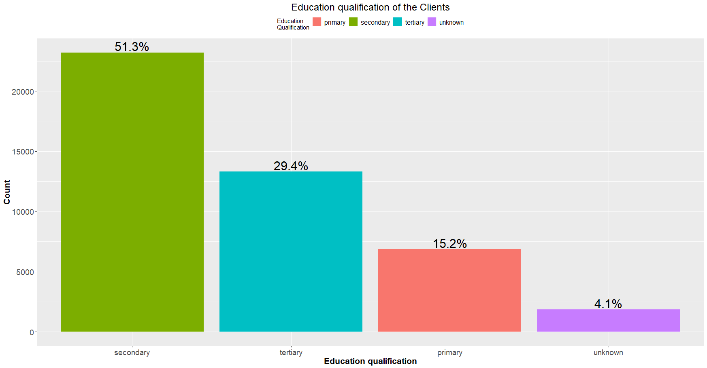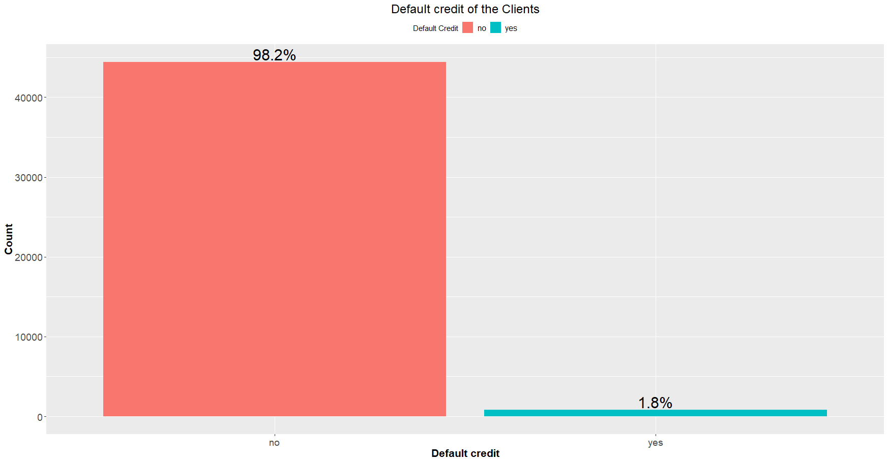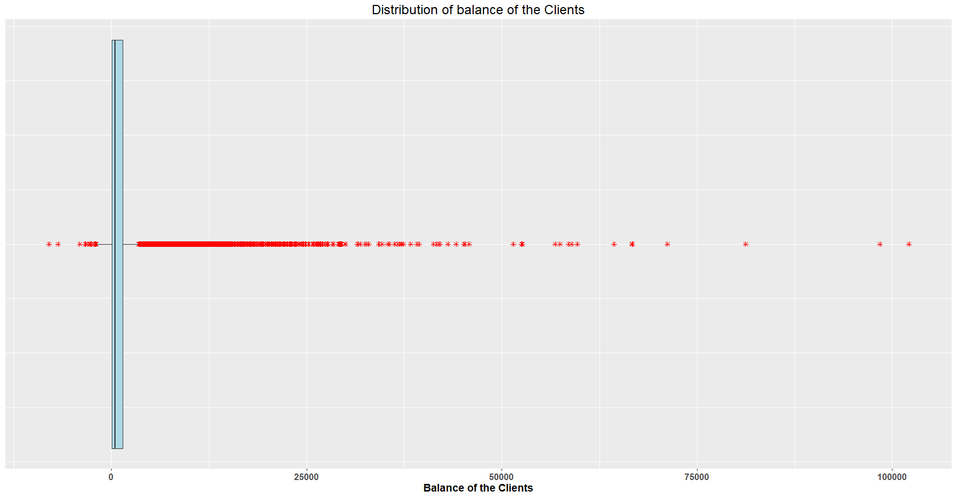

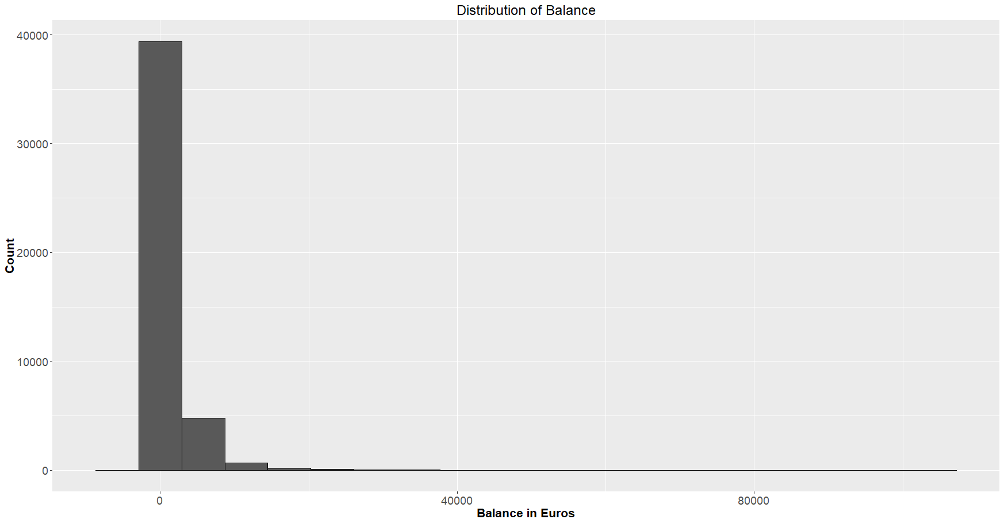

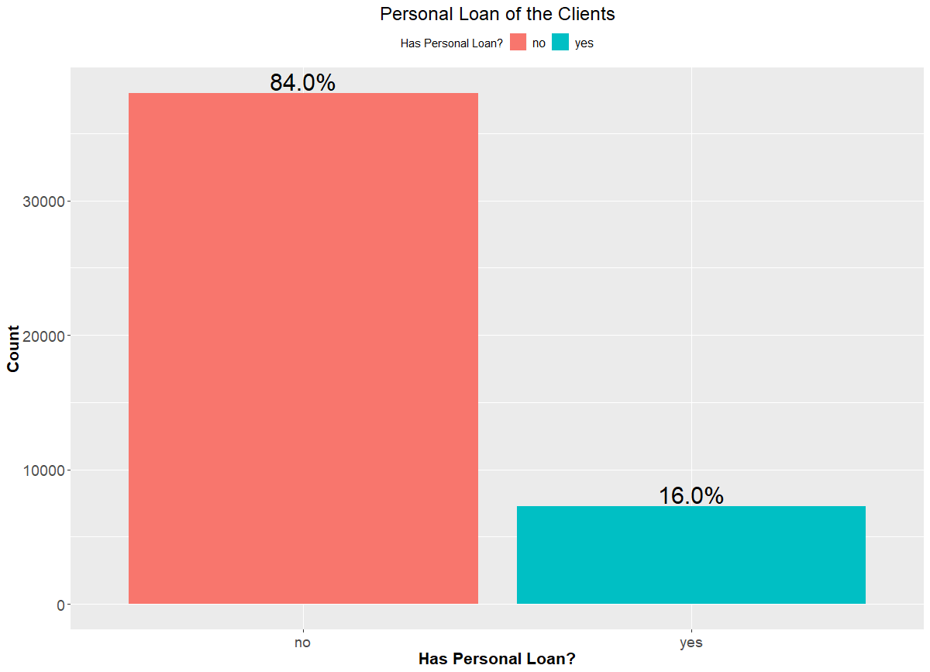

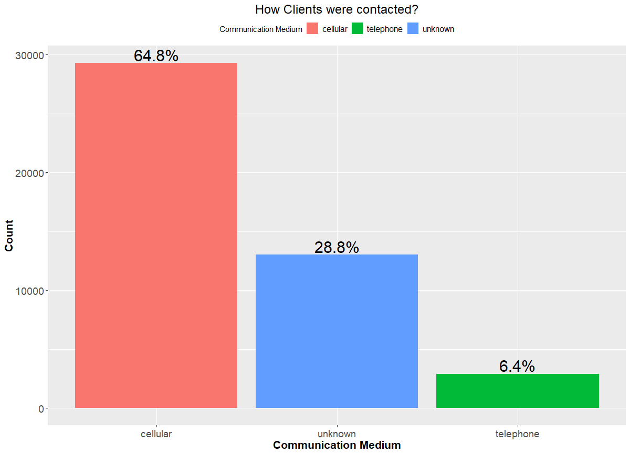

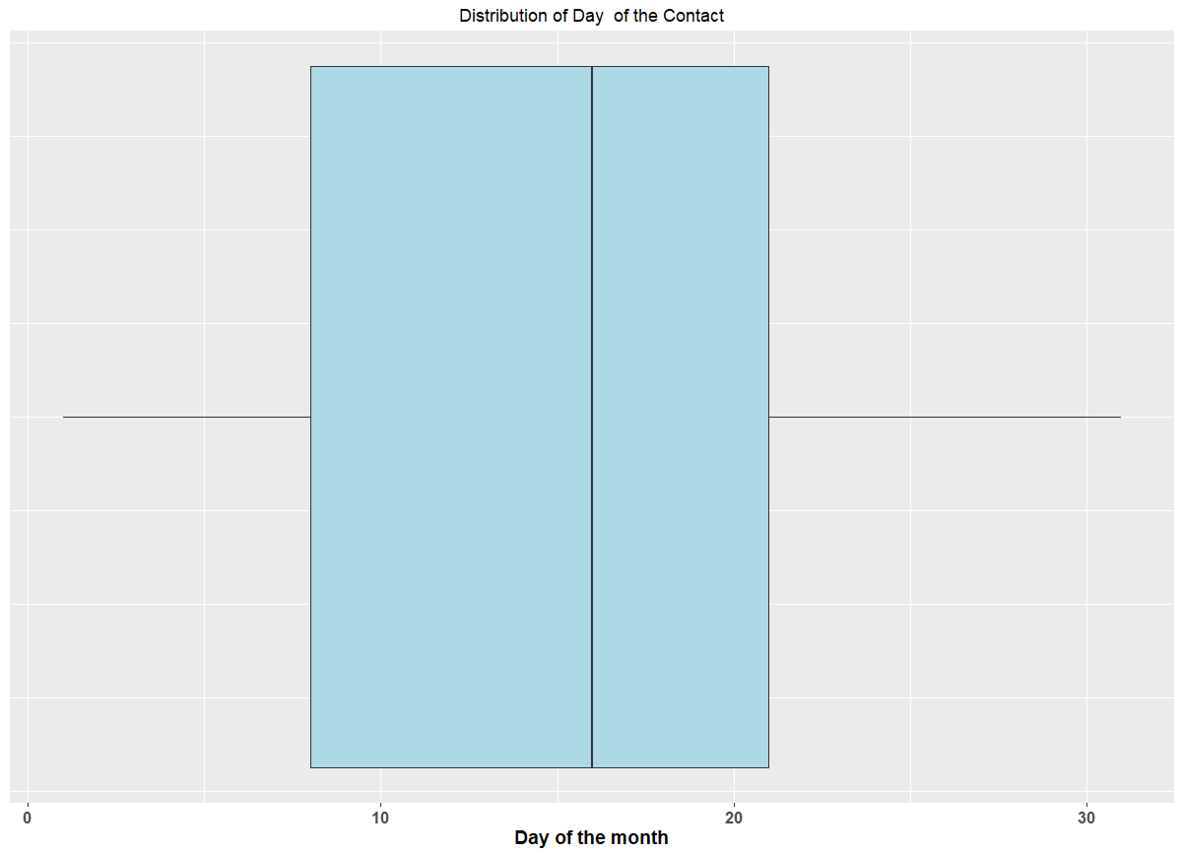

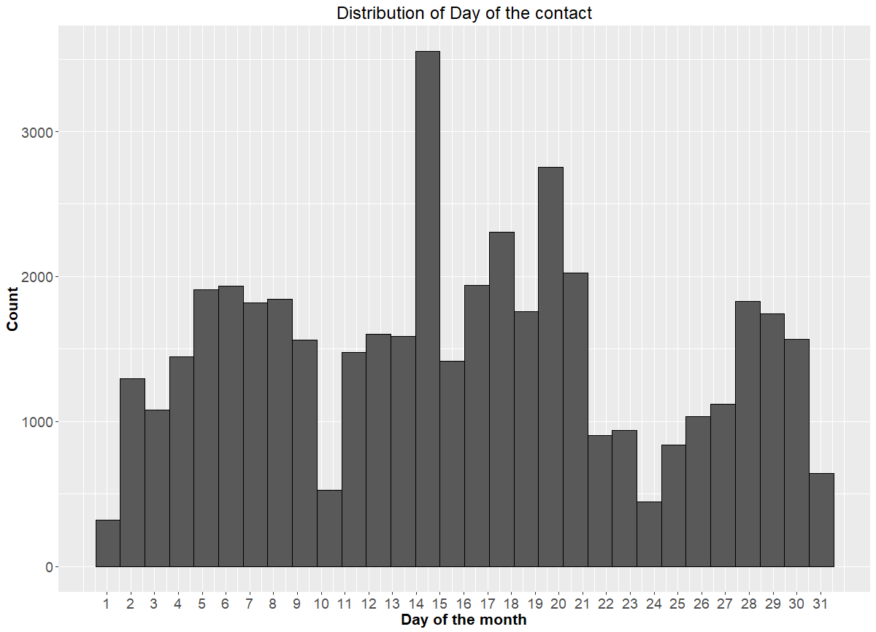



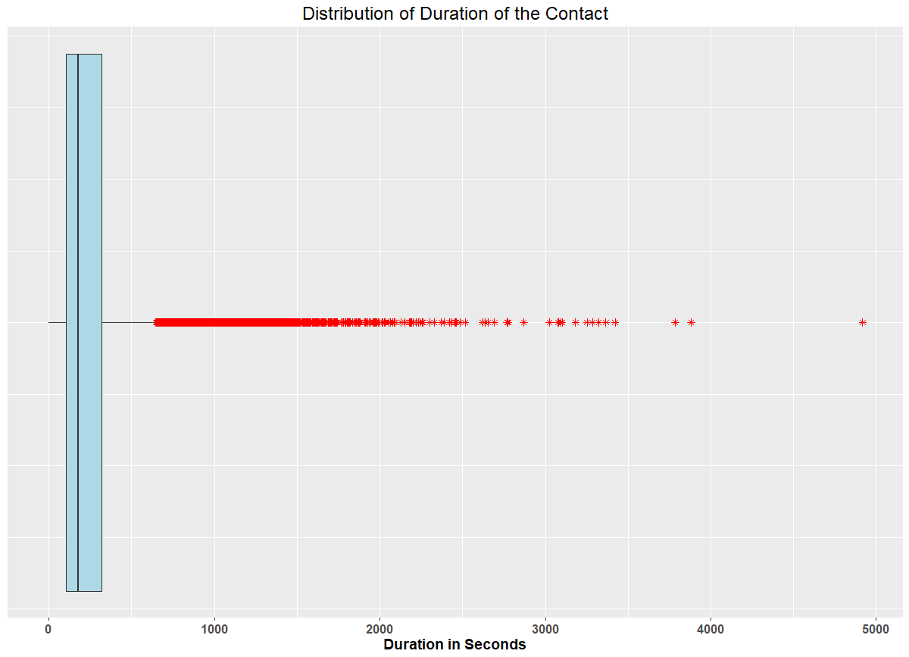

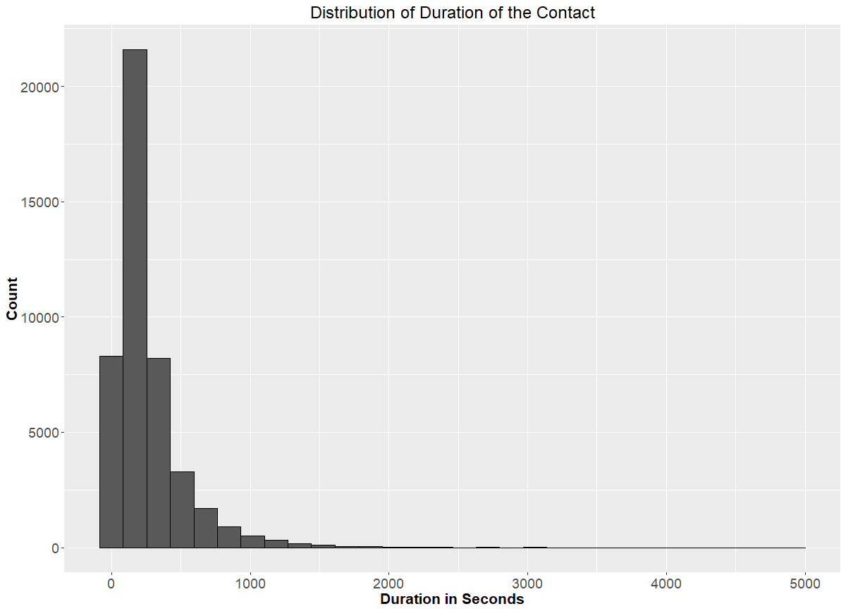

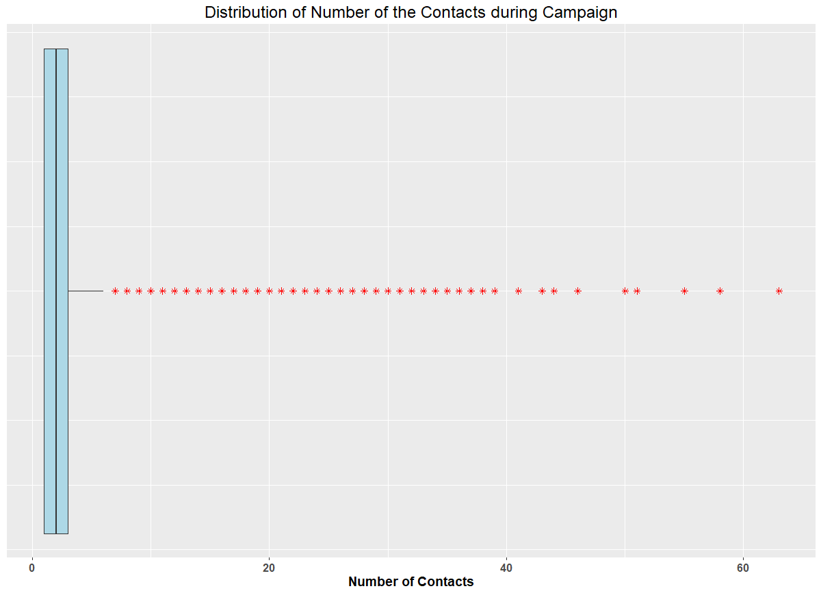

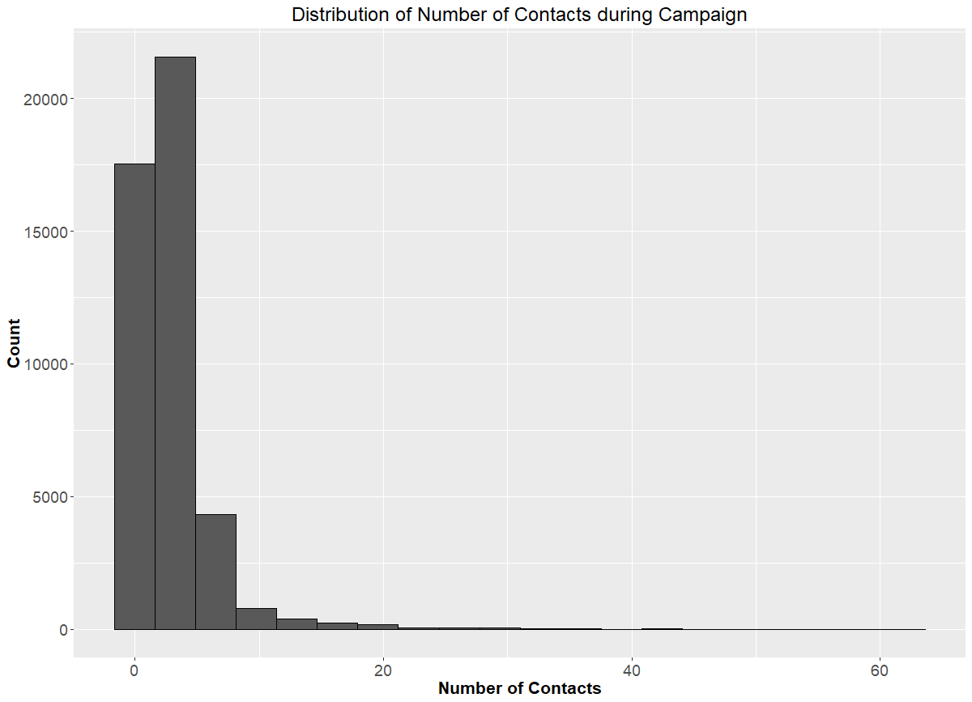

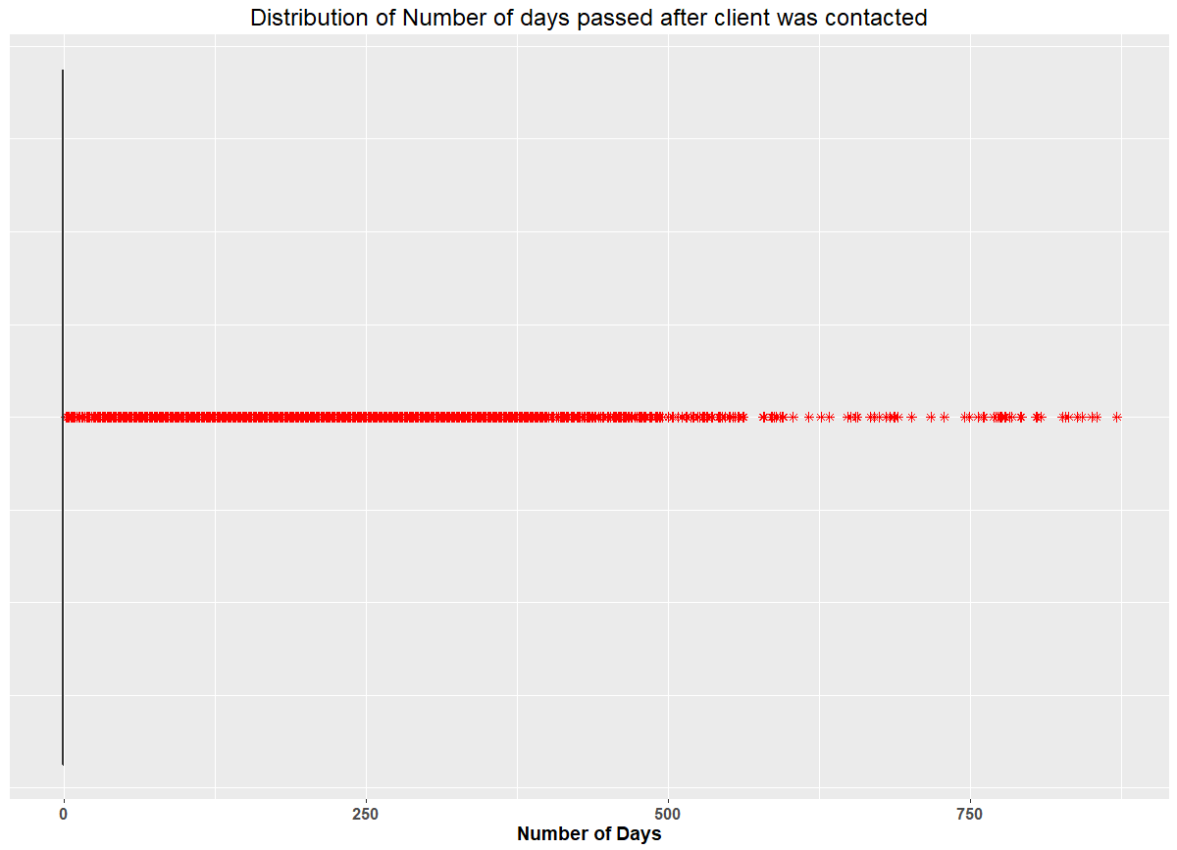

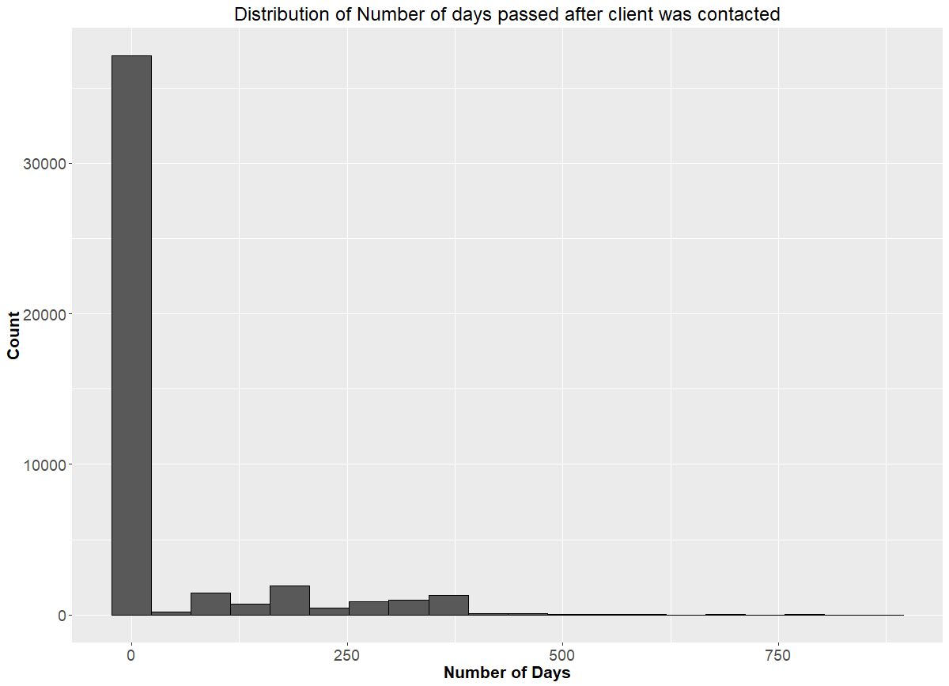

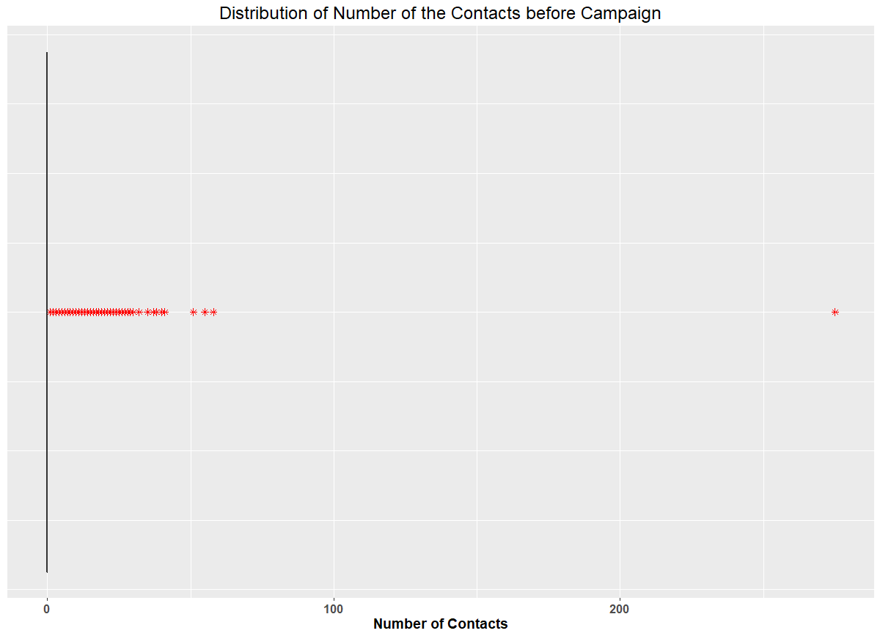

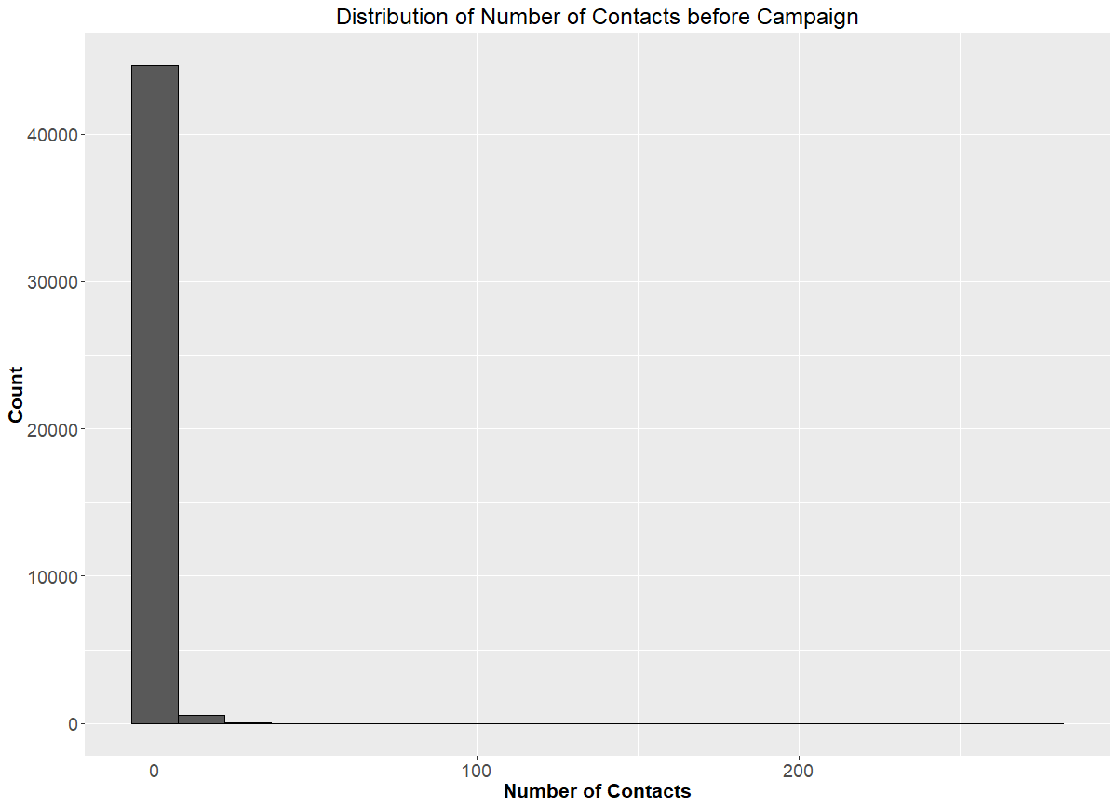

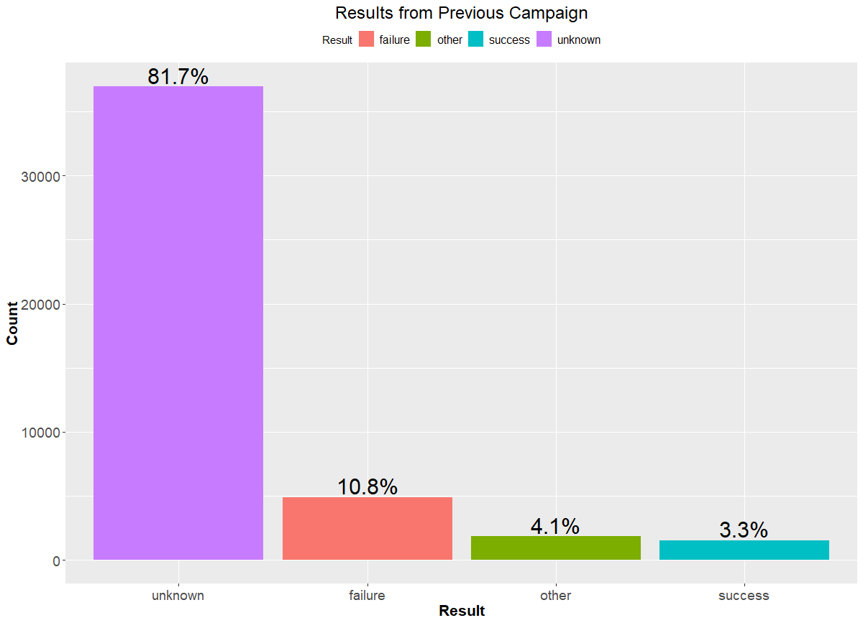

TREE Deviance split

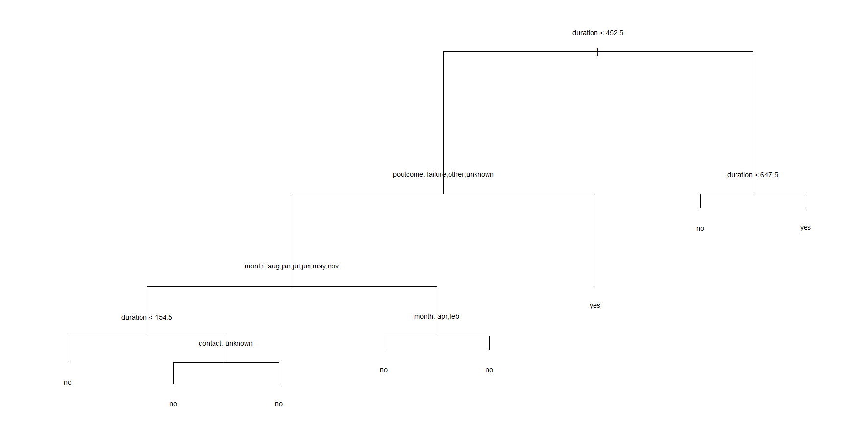

Pred:no Pred:yes

Actual:no 7562 400

Actual:yes 608 473 ACCURACY 88.85326

no yes

8110 932

**TREE GINI INDEX**

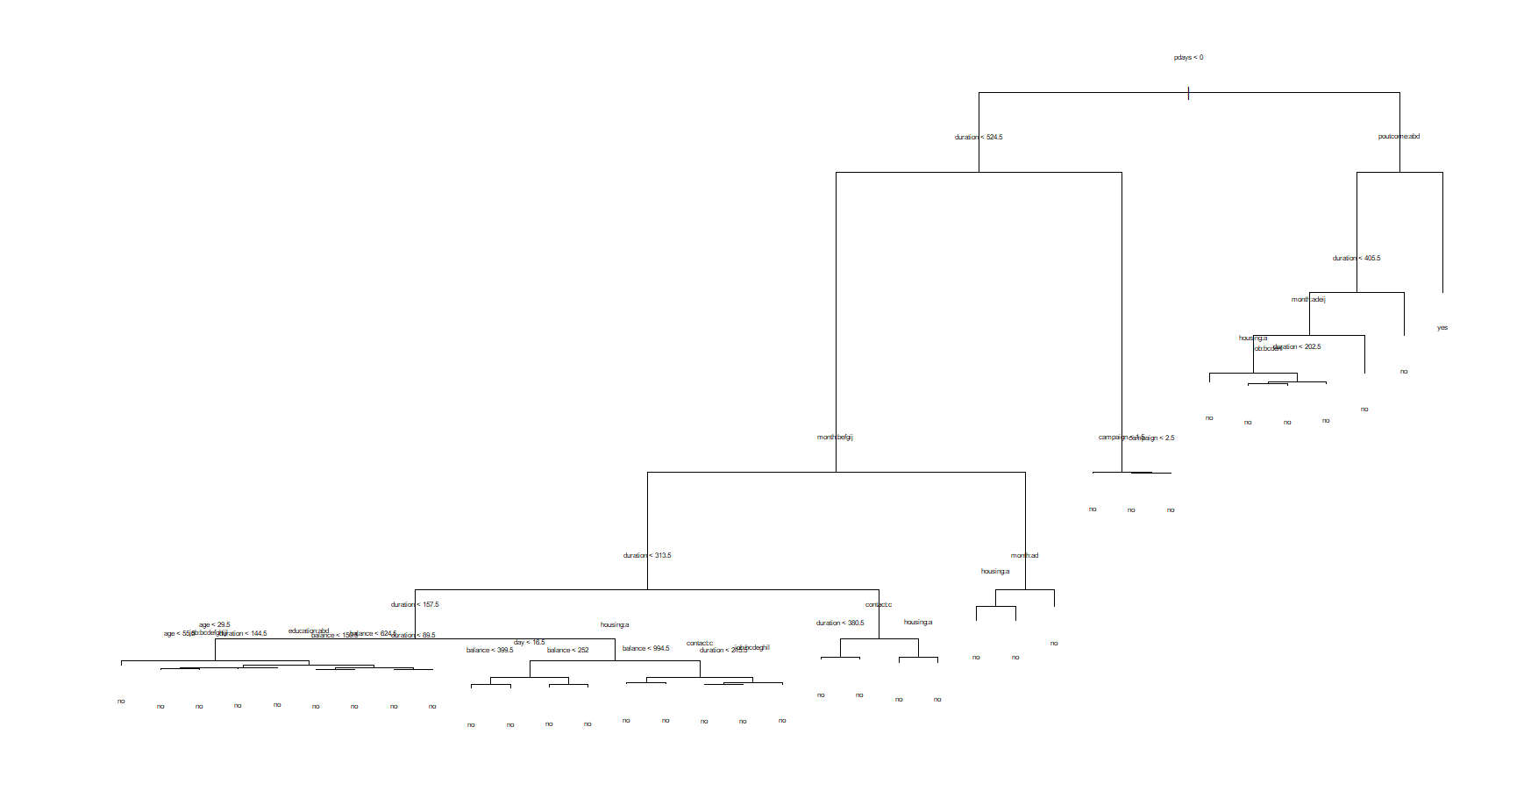

Pred:no Pred:yes

Actual:no 7869 93

Actual:yes 882 199 Accuracy 89.21818

no yes

8713 329

C5.0 TREE

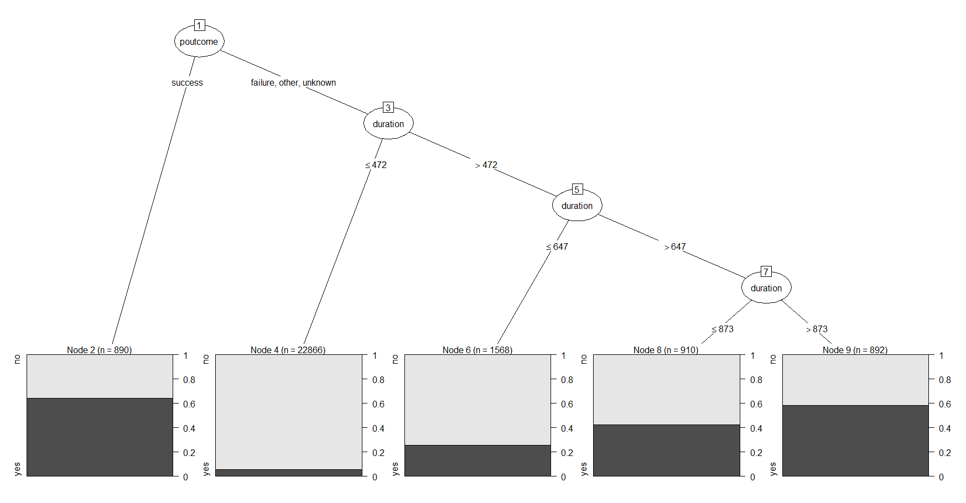

Pred:no Pred:yes

Actual:no 7740 222

Actual:yes 701 380 Accuracy 89.79321

no yes

8388 654

RULES USING C5.0

Rule 0/1: (25344/2043, lift 1.0)

duration <= 873

poutcome in {failure, other, unknown}

-> class no [0.919]

Rule 0/2: (890/316, lift 5.6)

poutcome = success

-> class yes [0.645]

Rule 0/3: (1877/910, lift 4.5)

duration > 647

-> class yes [0.515]

RPART TREE

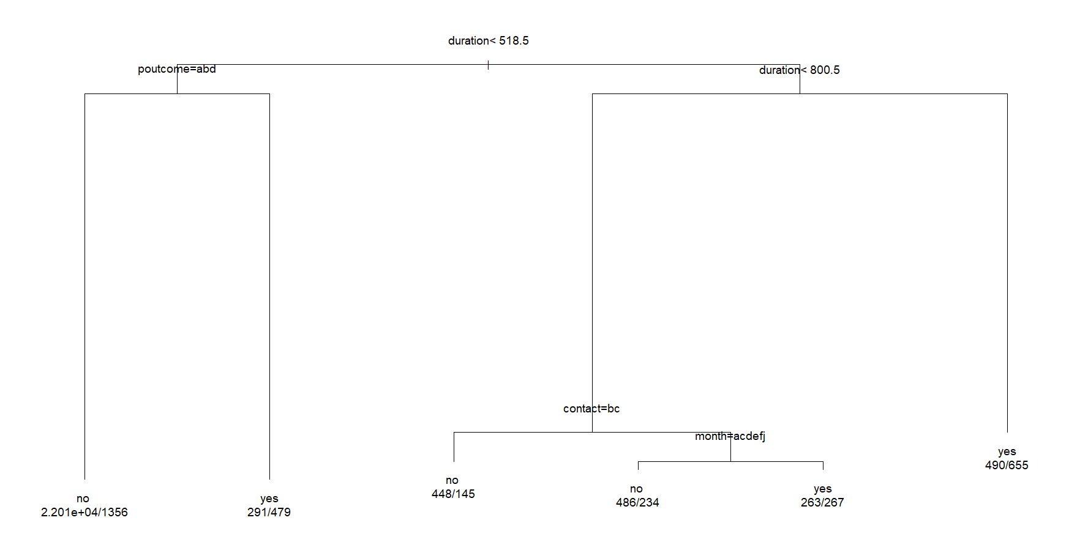

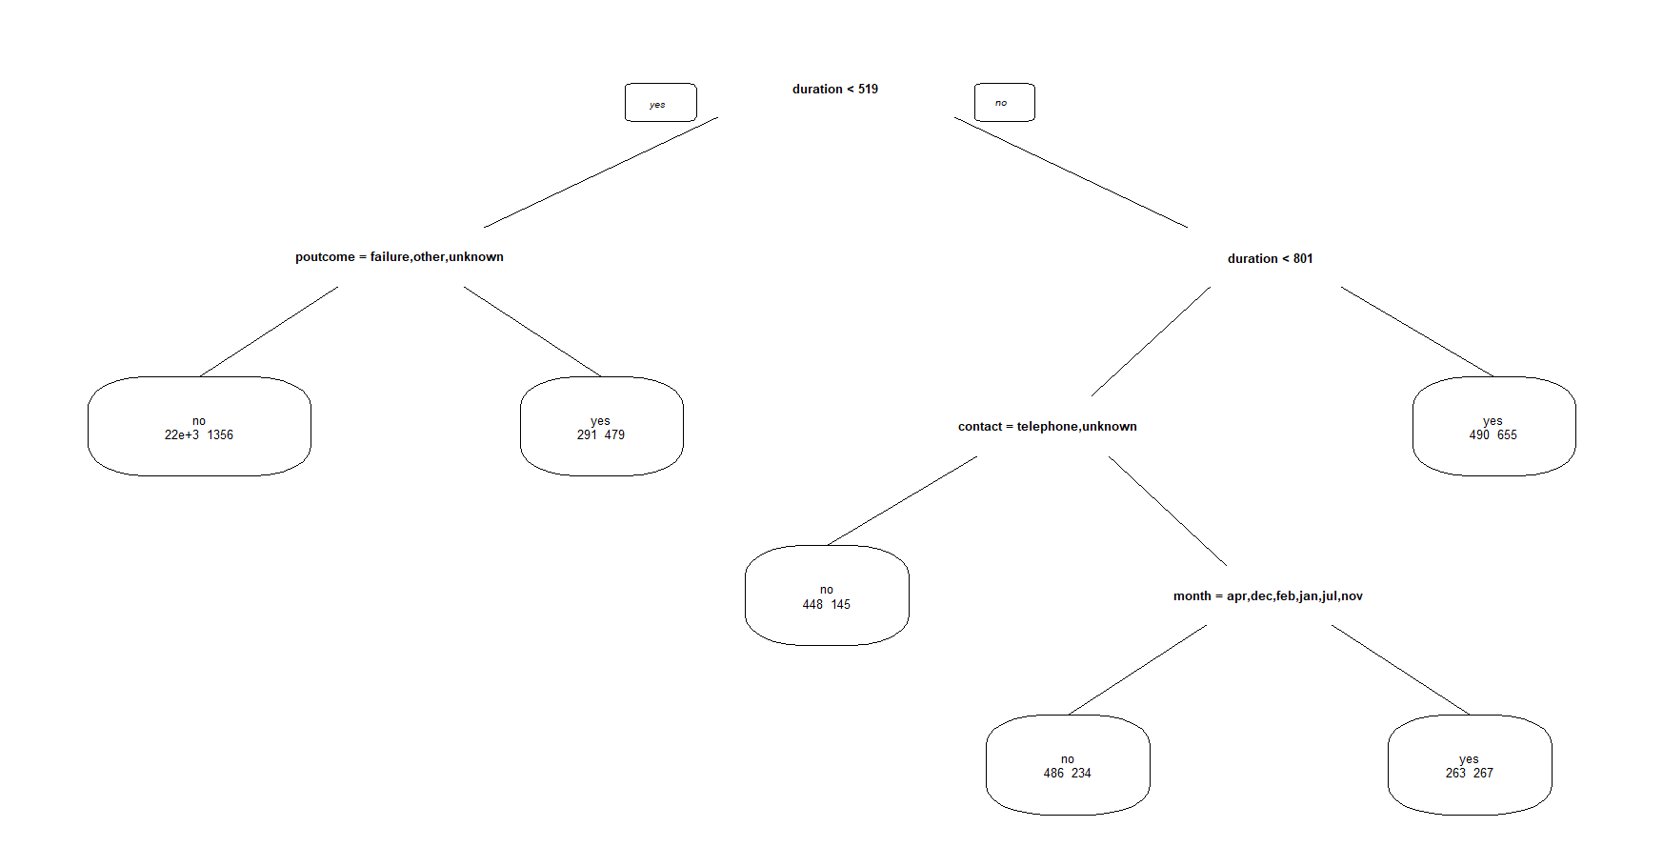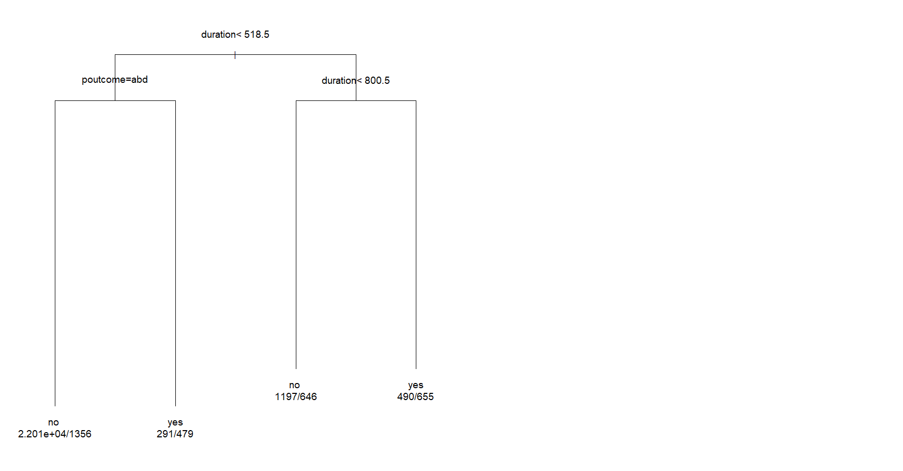

Pred:no Pred:yes

Actual:no 7712 250

Actual:yes 703 378 Accuracy 89.46146

no yes

8361 681

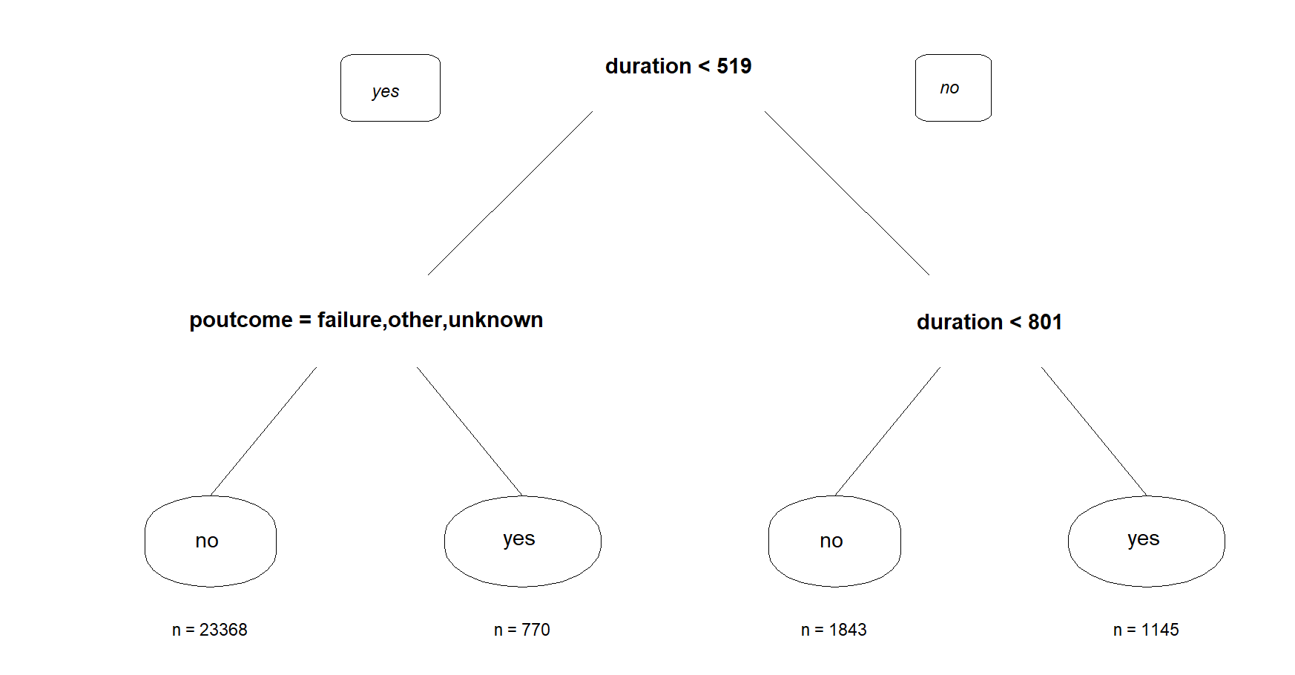 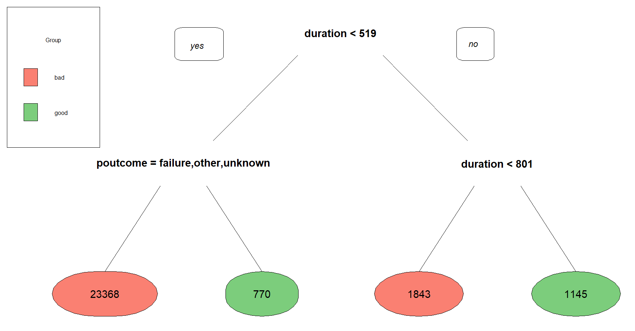

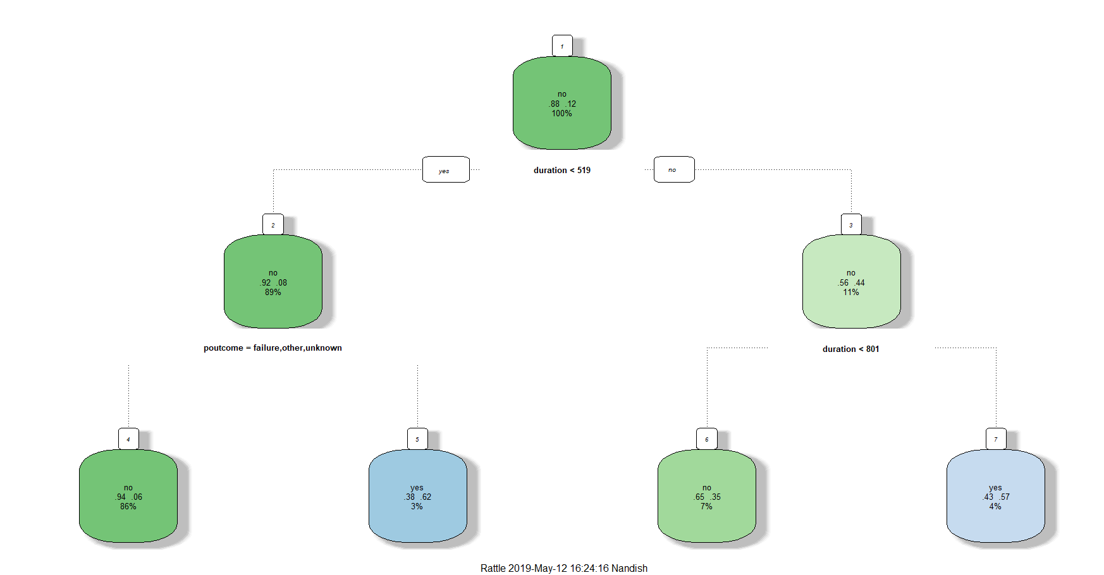

DEFAULT

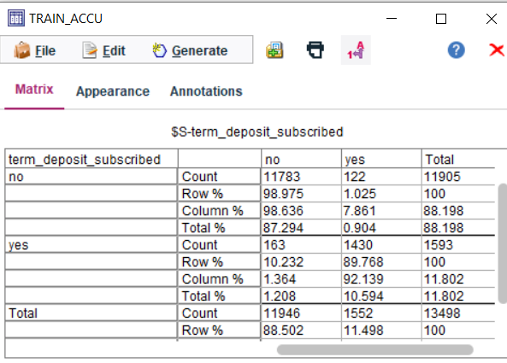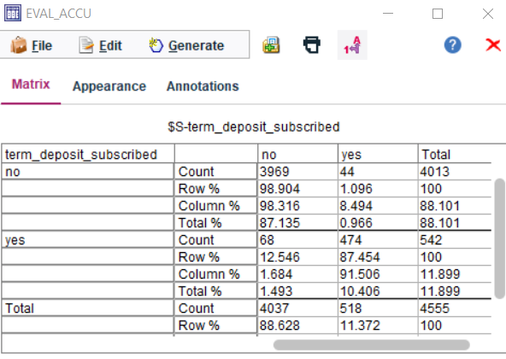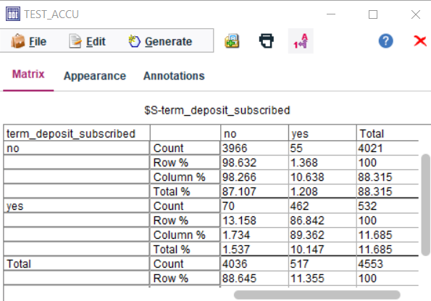

LINEAR KERNEL WITH DEFAULT SETTINGS

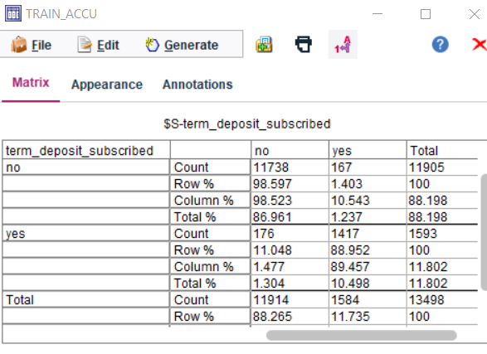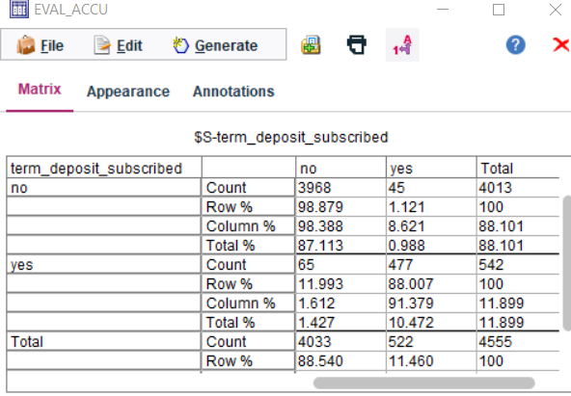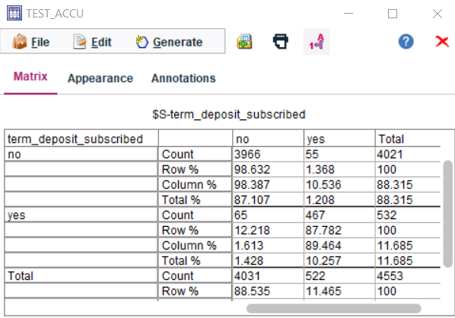

RBF WITH COST = 100 stop cri = 10-6 rbf gamma 0.1

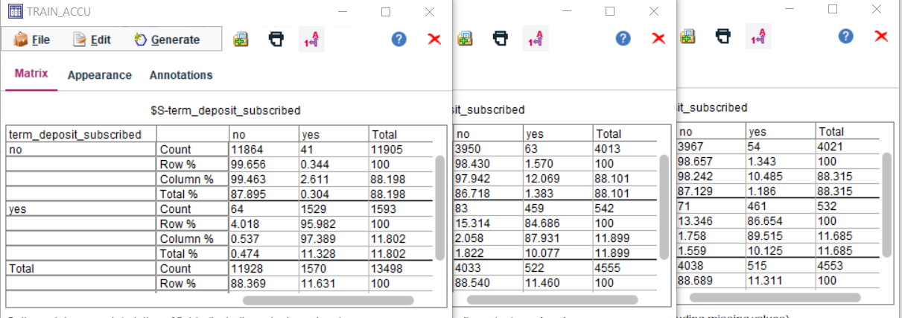

RBF cost = 10 rbf gamma = 0.2, stop = -3

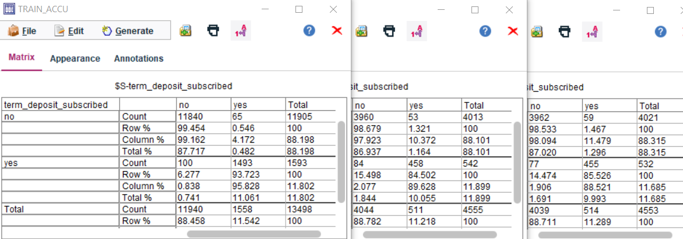

RBF cost = 100 rbf gamma = 0.2, stop = -3

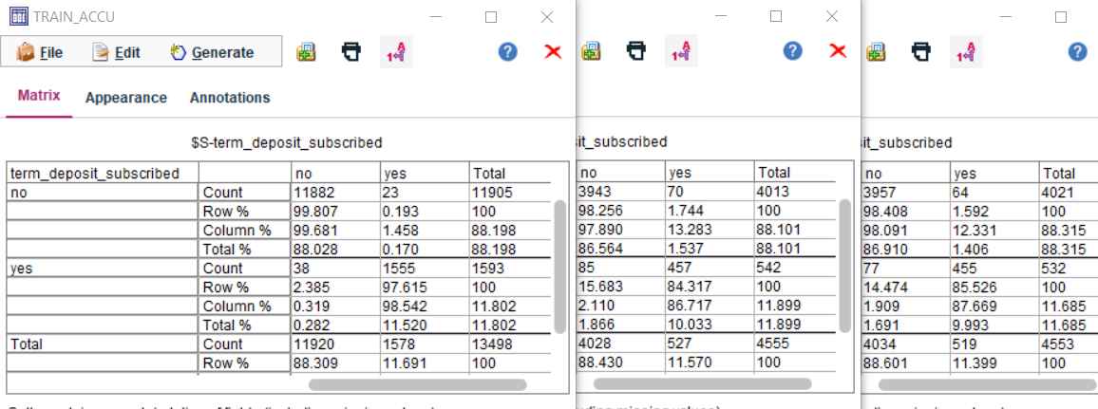

RBF cost = 100 rbf gamma = 0.2, stop = -3

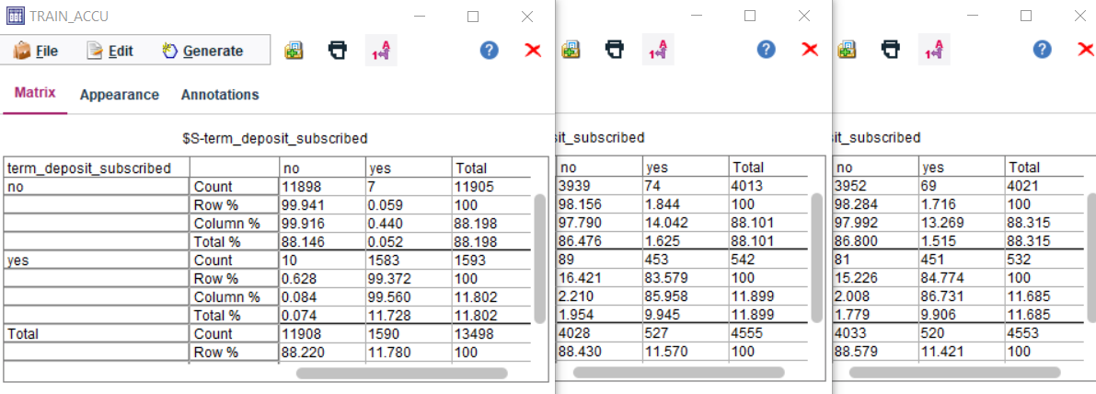

RBF cost = 10, rbf gamma = 0.25, stop = -3

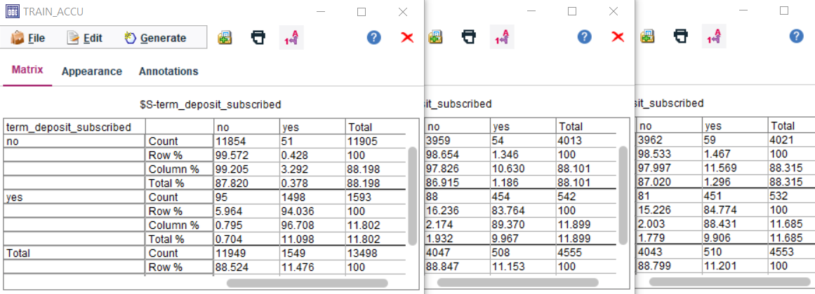

RBF cost = 10 gamma = -1 stop -3

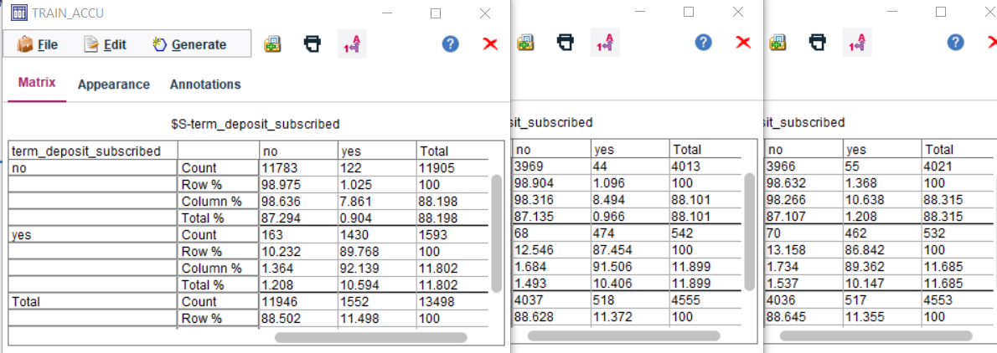

RBF cost = 100 gamma = -1 stop -3

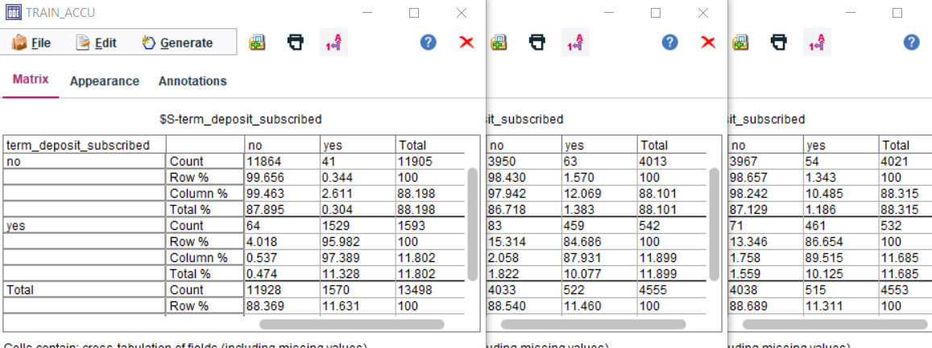

RBF cost = 1000 gamma = -1 stop -3

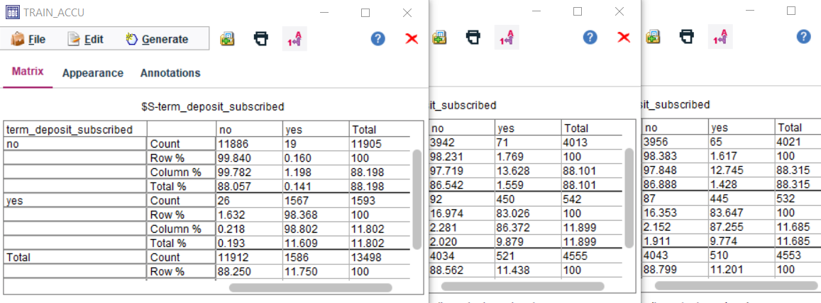

RBF cost = 10 gamma = -1 stop -5

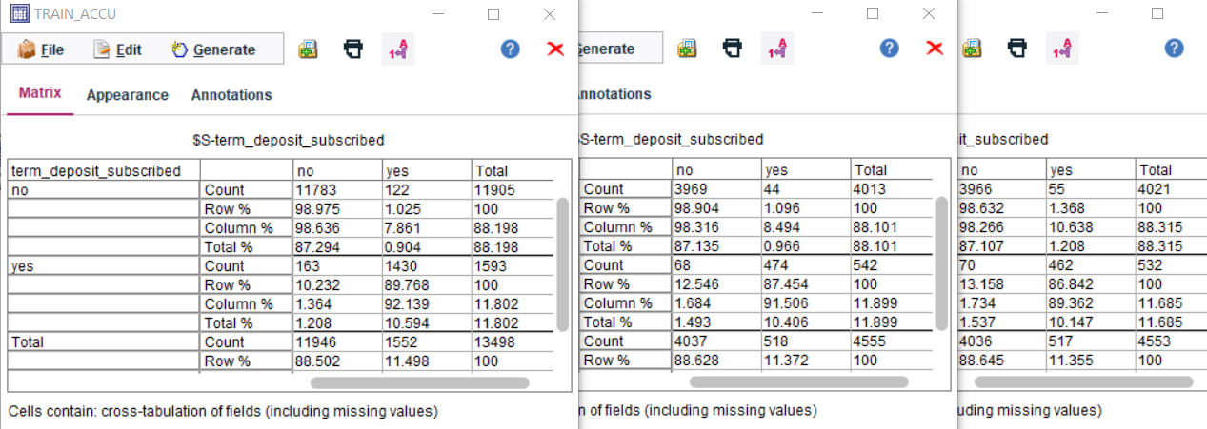

RBF cost = 100 gamma = -1 stop -5

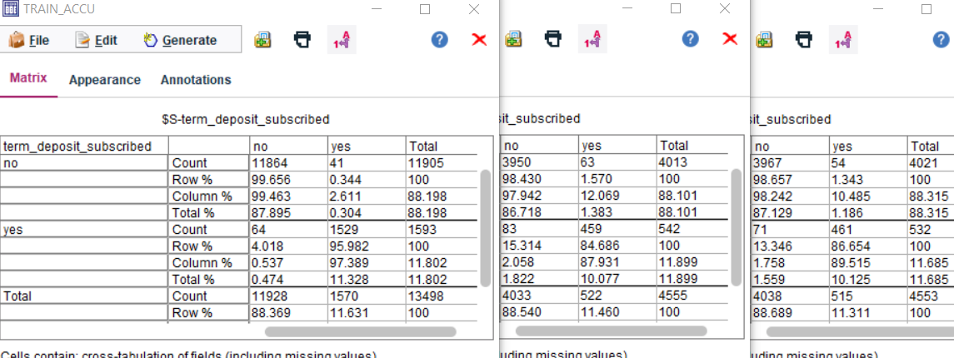

RBF cost = 1000 gamma = -1 stop -5

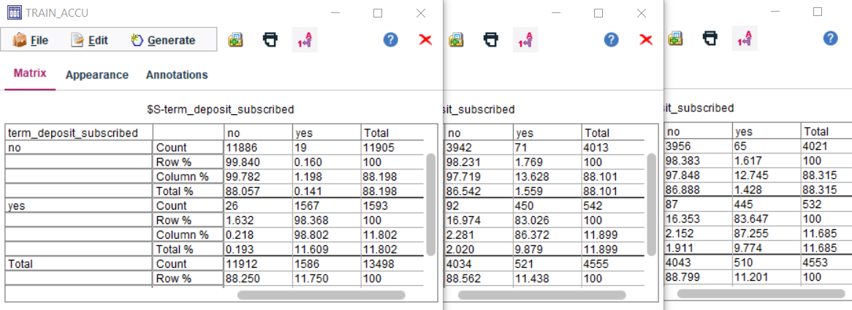

RBF cost = 10 gamma = -2 stop -3

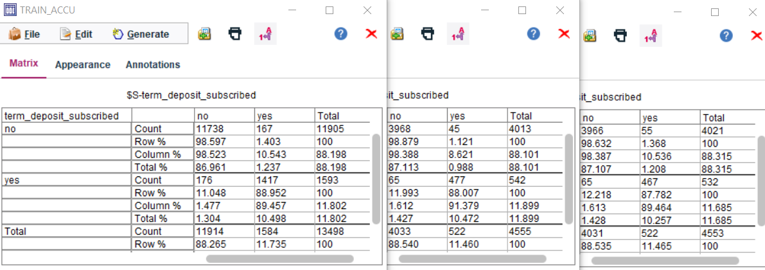

RBF cost = 100 gamma = -2 stop -3



RBF cost = 1000 gamma = -2 stop -3

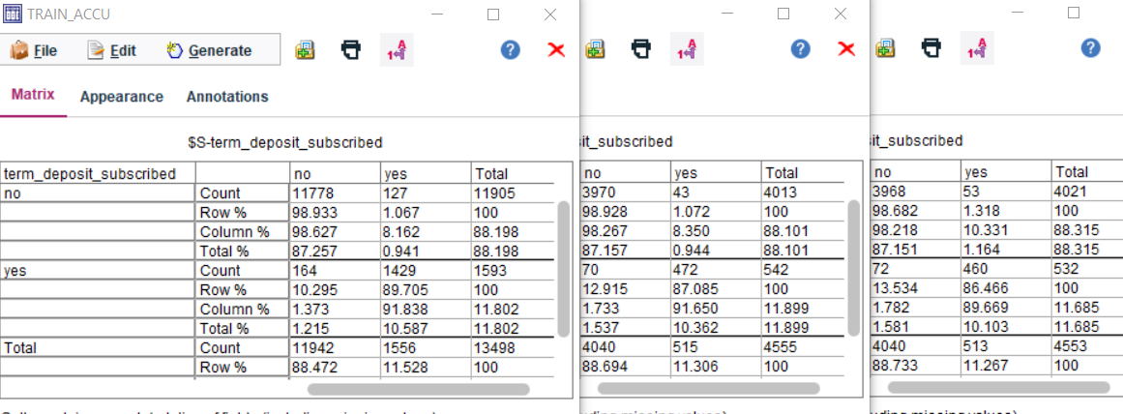

RBF cost = 10 gamma = -3 stop -3

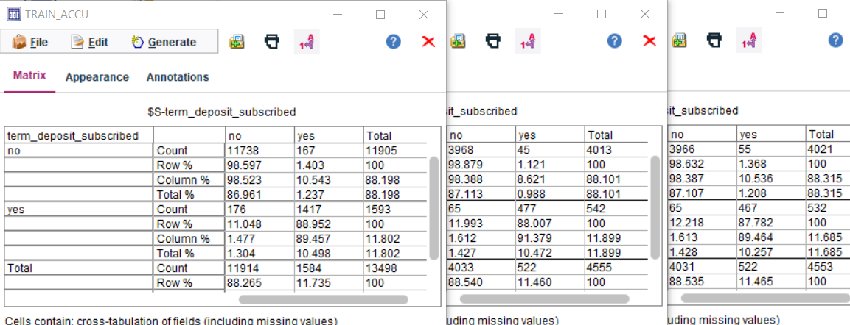

RBF cost = 100 gamma = -3 stop -3

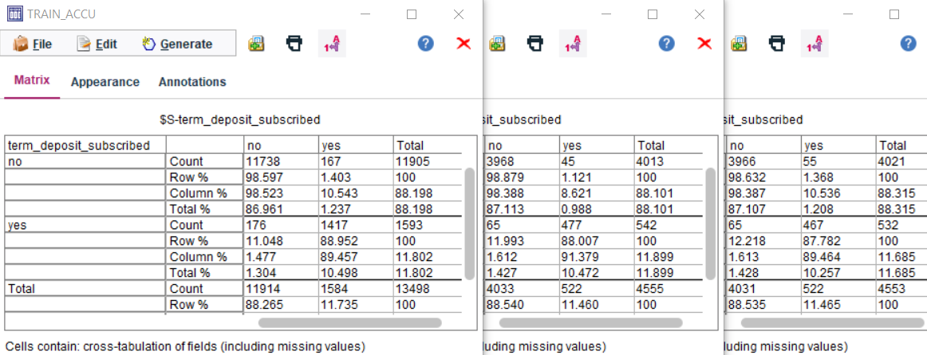

RBF cost = 1000 gamma = -3 stop -3

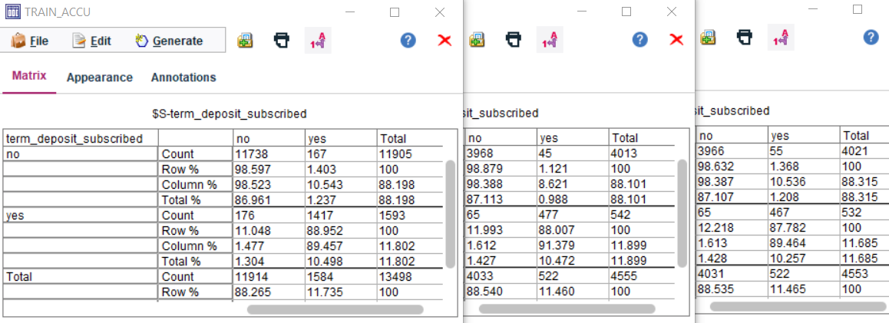

RBF cost = 10 gamma = -1 stop -4



RBF cost = 100 gamma = -1 stop -4



RBF cost = 1000 gamma = -1 stop -4



RBF cost = 10 gamma = -2 stop -4



RBF cost = 100 gamma = -2 stop -4



RBF cost = 1000 gamma = -2 stop -4



RBF cost = 10 gamma = -3 stop -4



RBF cost = 100 gamma = -3 stop -4



RBF cost = 1000 gamma = -3 stop -4

